Assignment 3 SQL Programming

Problem 1 through 30

RentalA Video is a movie rental store. It needs a database system to track the rental of movies to its members. RentalAVideo can own several copies (VIDEO) of each movie (MOVIE). For example, the store may have 10 copies of the movie “Gone with the Wind”. “Gone with the Wind” would be o ne MOVIE and each copy would be a VIDEO. A rental transaction (RENTAL) involves one or more videos being rented to a member (MEMBERSHIP). A video can be rented many times over its lifetime, therefore, there is a M:N relationship between RENTAL and VIDEO. DETAILRENTAL is the bridge table to resolve this relationship. The complete RDM is provided below.

RentalAVideo ERD (Figure 1)

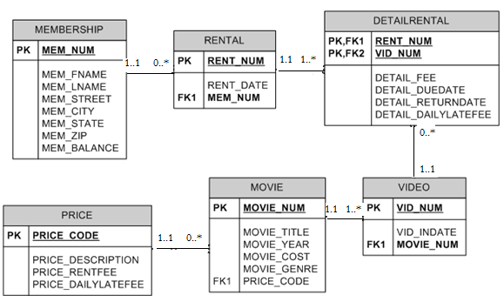

1. Write the SQL code to create the table structures for the entities shown in Figure 1. The structures should contain the specified attributes. Use data types that would be appropriate for the data that will need to be stored in each attribute. Enforce primary key and foreign key constraints as indicated by the ERD.

CREATE TABLE membership (

mem_num VARCHAR(30) NOT NULL,

mem_fname VARCHAR(30),

mem_lname VARCHAR(30),

mem_street VARCHAR(30),

mem_city VARCHAR(30),

mem_state VARCHAR(30),

mem_zip VARCHAR(30),

mem_balance NUMBER,

CONSTRAINT pk_membership PRIMARY KEY (mem_num)

);

CREATE TABLE rental (

rent_num VARCHAR(20) NOT NULL,

rant_date DATE,

mem_num VARCHAR(30),

CONSTRAINT pk_rental PRIMARY KEY (rent_num),

CONSTRAINT fk_rental FOREIGN KEY (mem_num) REFERENCES membership (mem_num)

);

CREATE TABLE detailrental (

rent_num VARCHAR(20) NOT NULL,

vid_num VARCHAR(20) NOT NULL,

detail_fee NUMBER,

detail_duedate DATE,

detail_returndate DATE,

detail_dailylatefee NUMBER,

CONSTRAINT pk_detailrental PRIMARY KEY (rent_num, vid_num),

CONSTRAINT fk_detailrental FOREIGN KEY (rent_num) REFERENCES rental (rent_num)

);

CREATE TABLE price (

price_code VARCHAR(30) NOT NULL,

price_description VARCHAR(30),

price_rentfee NUMBER,

price_dailylatefee NUMBER,

CONSTRAINT pk_price PRIMARY KEY (price_code)

);

CREATE TABLE movie (

movie_num VARCHAR(20) NOT NULL,

movie_title VARCHAR(20),

movie_year DATE,

movie_cost NUMBER,

movie_genre VARCHAR(20),

price_code VARCHAR(30),

CONSTRAINT pk_movie PRIMARY KEY (movie_num),

CONSTRAINT fk_movie FOREIGN KEY (price_code) REFERENCES price (price_code)

);

CREATE TABLE video (

vid_num VARCHAR(20) NOT NULL,

vid_indate DATE,

movie_num VARCHAR(20),

CONSTRAINT pk_video PRIMARY KEY (vid_num),

CONSTRAINT fk_video FOREIGN KEY (movie_num) REFERENCES movie (movie_num)

);

ALTER TABLE detailrental

ADD CONSTRAINT fk2_detailrental

FOREIGN KEY (vid_num) REFERENCES video (vid_num)

1. The following tables provide a very small portion of the data that will be kept in the database. This data needs to be inserted into the database for testing purposes. Write the INSERT commands necessary to place the following data in the tables that were created in problem 1.

|  |  |  |  |  |  |  |  |
| --- | --- | --- | --- | --- | --- | --- | --- |
| **MEMBERSHIP** | | | | | | | |
| **Mem_ Num** | **Mem_ Fname** | **Mem_ Lname** | **Mem_Street** | **Mem_City** | **Mem_ State** | **Mem_Zip** | **Mem_ Balance** |
| 102 | Tami | Dawson | 2632 Takli Circle | Norene | TN | 37136 | 11 |
| 103 | Curt | Knight | 4025 Cornell Court | Flatgap | KY | 41219 | 6 |
| 104 | Jamal | Melendez | 788 East 145th Avenue | Quebeck | TN | 38579 | 0 |
| 105 | Iva | Mcclain | 6045 Musket Ball Circle | Summit | KY | 42783 | 15 |
| 106 | Miranda | Parks | 4469 Maxwell Place | Germantown | TN | 38183 | 0 |
| 107 | Rosario | Elliott | 7578 Danner Avenue | Columbia | TN | 38402 | 5 |
| 108 | Mattie | Guy | 4390 Evergreen Street | Lily | KY | 40740 | 0 |
| 109 | Clint | Ochoa | 1711 Elm Street | Greeneville | TN | 37745 | 10 |
| 110 | Lewis | Rosales | 4524 Southwind Circle | Counce | TN | 38326 | 0 |
| 111 | Stacy | Mann | 2789 East Cook Avenue | Murfreesboro | TN | 37132 | 8 |
| 112 | Luis | Trujillo | 7267 Melvin Avenue | Heiskell | TN | 37754 | 3 |
| 113 | Minnie | Gonzales | 6430 Vasili Drive | Williston | TN | 38076 | 0 |

|  |  |  |
| --- | --- | --- |
| **RENTAL** | | |
| **Rent_Num** | **Rent_Date** | **Mem_Num** |
| 1001 | 01-MAR-09 | 103 |
| 1002 | 01-MAR-09 | 105 |
| 1003 | 02-MAR-09 | 102 |
| 1004 | 02-MAR-09 | 110 |
| 1005 | 02-MAR-09 | 111 |
| 1006 | 02-MAR-09 | 107 |
| 1007 | 02-MAR-09 | 104 |
| 1008 | 03-MAR-09 | 105 |
| 1009 | 03-MAR-09 | 111 |

|  |  |  |
| --- | --- | --- |
| **VIDEO** | | |
| **Vid_Num** | **Vid_Indate** | **Movie_Num** |
| 54321 | 18-JUN-08 | 1234 |
| 54324 | 18-JUN-08 | 1234 |
| 54325 | 18-JUN-08 | 1234 |
| 34341 | 22-JAN-07 | 1235 |
| 34342 | 22-JAN-07 | 1235 |
| 34366 | 02-MAR-09 | 1236 |
| 34367 | 02-MAR-09 | 1236 |
| 34368 | 02-MAR-09 | 1236 |
| 34369 | 02-MAR-09 | 1236 |
| 44392 | 21-OCT-08 | 1237 |
| 44397 | 21-OCT-08 | 1237 |
| 59237 | 14-FEB-09 | 1237 |
| 61388 | 25-JAN-07 | 1239 |
| 61353 | 28-JAN-06 | 1245 |
| 61354 | 28-JAN-06 | 1245 |
| 61367 | 30-JUL-08 | 1246 |
| 61369 | 30-JUL-08 | 1246 |

|  |  |  |  |  |  |
| --- | --- | --- | --- | --- | --- |
| **DETAILRENTAL** | | | | | |
| **Rent_Num** | **Vid_Num** | **Detail_Fee** | **Detail_Duedate** | **Detail_Returndate** | **Detail_Dailylatefee** |
| 1001 | 34342 | 2 | 04-MAR-09 | 02-MAR-09 | 1 |
| 1001 | 61353 | 2 | 04-MAR-09 | 03-MAR-09 | 1 |
| 1002 | 59237 | 3.5 | 04-MAR-09 | 04-MAR-09 | 3 |
| 1003 | 54325 | 3.5 | 04-MAR-09 | 09-MAR-09 | 3 |
| 1003 | 61369 | 2 | 06-MAR-09 | 09-MAR-09 | 1 |
| 1003 | 61388 | 0 | 06-MAR-09 | 09-MAR-09 | 1 |
| 1004 | 44392 | 3.5 | 05-MAR-09 | 07-MAR-09 | 3 |
| 1004 | 34367 | 3.5 | 05-MAR-09 | 07-MAR-09 | 3 |
| 1004 | 34341 | 2 | 07-MAR-09 | 07-MAR-09 | 1 |
| 1005 | 34342 | 2 | 07-MAR-09 | 05-MAR-09 | 1 |
| 1005 | 44397 | 3.5 | 05-MAR-09 | 05-MAR-09 | 3 |
| 1006 | 34366 | 3.5 | 05-MAR-09 | 04-MAR-09 | 3 |
| 1006 | 61367 | 2 | 07-MAR-09 |  | 1 |
| 1007 | 34368 | 3.5 | 05-MAR-09 |  | 3 |
| 1008 | 34369 | 3.5 | 05-MAR-09 | 05-MAR-09 | 3 |
| 1009 | 54324 | 3.5 | 05-MAR-09 |  | 3 |
| 1001 | 34366 | 3.5 | 04-MAR-09 | 02-MAR-09 | 3 |

|  |  |  |  |  |  |
| --- | --- | --- | --- | --- | --- |
| **MOVIE** | | | | | |
| **Movie_Num** | **Movie_Name** | **Movie_Year** | **Movie_Cost** | **Movie_Genre** | **Price_Code** |
| 1234 | The Cesar Family Christmas | 2007 | 39.95 | FAMILY | 2 |
| 1235 | Smokey Mountain Wildlife | 2004 | 59.95 | ACTION | 1 |
| 1236 | Richard Goodhope | 2008 | 59.95 | DRAMA | 2 |
| 1237 | Beatnik Fever | 2007 | 29.95 | COMEDY | 2 |
| 1238 | Constant Companion | 2008 | 89.95 | DRAMA | 2 |
| 1239 | Where Hope Dies | 1998 | 25.49 | DRAMA | 3 |
| 1245 | Time to Burn | 2005 | 45.49 | ACTION | 1 |
| 1246 | What He Doesn't Know | 2006 | 58.29 | COMEDY | 1 |

|  |  |  |  |
| --- | --- | --- | --- |
| **PRICE** | | | |
| **Price_Code** | **Price_Description** | **Price_Rentfee** | **Price_Dailylatefee** |
| 1 | Standard | 2 | 1 |
| 2 | New Release | 3.5 | 3 |
| 3 | Discount | 1.5 | 1 |
| 4 | Weekly Special | 1 | .5 |

INSERT INTO membership VALUES ( "102", "Tami", "Dawson", "2632 Takli Circle", "Norene", "TN", "37136", 11)

INSERT INTO rental VALUES ( "1003", #02-MAR-09#, "102")

INSERT INTO detailrental VALUES ( "1003", "61369", 2, #09-MAR-09#, #02-MAR-09#, 1)

INSERT INTO price VALUES ( "1", "Standard", 2, 1)

INSERT INTO movie VALUES ( "1246", "What he doesn't know", ‘2006’, 58.29, "COMEDY", "1")

INSERT INTO video VALUES ( "61369", #30-JUL-08#, "1246")

For questions 3– 31, use the tables that were created in Problem 1 and the data that was loaded into those tables in Problem 2.

1. Write the SQL command to change the movie year for movie number 1245 to 2006.

UPDATE movie

SET movie_year = "2006"

WHERE movie_num = "1245"

1. Write the SQL command to change the price code for all Action movies to price code 3.

UPDATE movie

SET price_code = "3"

WHERE Movie_Genre = "ACTION"

1. Write a single SQL command to increase all price rental fee values by $0.50.

UPDATE price

SET Price_Rentfee = Price_Rentfee + 0.50

1. Write a query to display the movie title, movie year, and movie genre for all movies.

SELECT Movie_Name, Movie_Year, Movie_Genre

FROM movie

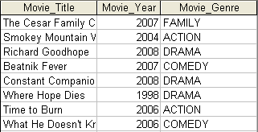

1. Write a query to display the movie year, movie title, and movie cost sorted by movie year in descending order.

SELECT Movie_Year, Movie_Name, Movie_Cost

FROM movie

ORDER BY Movie_Year DESC

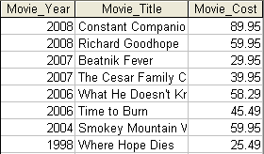

1. Write a query to display the movie title, movie year, and movie genre for all movies sorted by movie genre in ascending order, then sorted by movie year in descending order within genre.

SELECT Movie_Name, Movie_Year, Movie_Genre

FROM movie

ORDER BY Movie_Genre, Movie_Year DESC

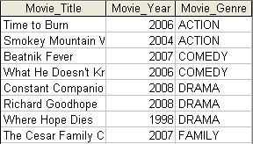

1. Write a query to display the movie number, movie title, and price code for all movies with a title that starts with the letter “R”.

SELECT Movie_Num, Movie_Name, Price_Code

FROM movie

WHERE Movie_Name LIKE "R*"



1. Write a query to display the movie title, movie year, and movie cost for all movies that contain the word “hope” anywhere in the title. Sort the results in ascending order by title.

SELECT Movie_Name, Movie_Year, Movie_Cost

FROM movie

WHERE Movie_Name LIKE "*hope*"

ORDER BY Movie_Name



1. Write a query to display the movie title, movie year, and movie genre for all action movies.

SELECT Movie_Name, Movie_Year, Movie_Genre

FROM movie

WHERE Movie_Genre = "ACTION"



1. Write a query to display the movie number, movie title, and movie cost for all movies with a cost greater than $40.

SELECT Movie_Num, Movie_Name, Movie_Cost

FROM movie

WHERE Movie_Cost > "40"

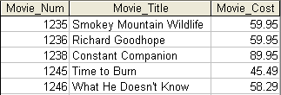

1. Write a query to display the movie number, movie title, movie cost, and movie genre for movies that are either action or comedy movies or movies that have a cost that is less than $50. Sort the results in ascending order by genre.

SELECT Movie_Num, Movie_Name, Movie_Cost, Movie_Genre

FROM movie

WHERE Movie_Genre = "ACTION" OR Movie_Genre = "COMEDY" OR Movie_Cost < "50"

ORDER BY Movie_Genre

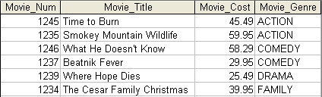

1. Write a query to display the movie genre and the number of movies in each genre.

SELECT Movie_Genre, COUNT(Movie_Genre) AS Number_of_Movies

FROM movie

GROUP BY Movie_Genre

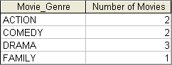

1. Write a query to display the average cost of all of the movies.

SELECT AVG(Movie_Cost) AS Average_Movie_Cost

FROM movie



1. Write a query to display the movie genre and average cost of movies in each genre.

SELECT Movie_Genre, Round(AVG(Movie_Cost), 2) AS Average_Cost

FROM movie

GROUP BY Movie_Genre

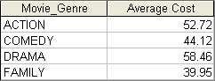

1. Write a query to display the movie title, movie genre, price description, and price rental fee for all movies with a price code.

SELECT m.Movie_Name, m.Movie_Genre, p.Price_Description, p.Price_Rentfee

FROM movie m, price p

WHERE m.Price_Code = p.Price_Code

|  |  |  |  |
| --- | --- | --- | --- |
| Movie_Title | Movie_Genre | Price_Descriptioin | Price_Rentfee |
| What He Doesn't Know | COMEDY | Standard | 2.5 |
| The Cesar Family Christmas | FAMILY | New Release | 4 |
| Richard Goodhope | DRAMA | New Release | 4 |
| Beatnik Fever | COMEDY | New Release | 4 |
| Constant Companion | DRAMA | New Release | 4 |
| Smokey Mountain Wildlife | ACTION | Discount | 2 |
| Where Hope Dies | DRAMA | Discount | 2 |
| Time to Burn | ACTION | Discount | 2 |

1. Write a query to display the movie genre and average price rental fee for movies in each genre that have a price.

SELECT Movie_Genre, ROUND(AVG(Price_Rentfee), 2) AS Average_Rental_Fee

FROM movie, price

WHERE movie.Price_Code = price.Price_Code

GROUP BY Movie_Genre

|  |  |
| --- | --- |
| Movie_Genre | AVERAGE_RENTAL_FEE |
| FAMILY | 4 |
| COMEDY | 3.25 |
| ACTION | 2 |
| DRAMA | 3.33 |

1. Write a query to display the movie title, movie year, and the movie cost divided by the price rental fee for each movie that has a price to determine the number of rentals it will take to break even on the purchase of the movie.

SELECT Movie_Name, Movie_Year, ROUND(Movie_Cost/Price_Rentfee, 2) AS Breakeven_Rentals

FROM movie, price

WHERE movie.Price_Code = price.Price_Code

|  |  |  |
| --- | --- | --- |
| MOVIE_TITLE | MOVIE_YEAR | BREAKEVEN_RENTALS |
| What He Doesn't Know | 2006 | 23.32 |
| Richard Goodhope | 2008 | 14.99 |
| The Cesar Family | 2007 | 9.99 |
| Beatnik Fever | 2007 | 7.49 |
| Constant Companion | 2008 | 22.49 |
| Where Hope Dies | 1998 | 12.75 |
| Time to Burn | 2006 | 22.75 |
| Smokey Mountain Wildlife | 2004 | 29.98 |

1. Write a query to display the movie title and movie year for all movies that have a price code.

SELECT Movie_Name, Movie_Year

FROM movie

ORDER BY Movie_Name

| **MOVIE_TITLE** | **MOVIE_YEAR** |
| --- | --- |
| Beatnik Fever | 2007 |
| Constant Companion | 2008 |
| Richard Goodhope | 2008 |
| Smokey Mountain Wildlife | 2004 |
| Time to Burn | 2005 |
| What He Doesn't Know | 2006 |
| Where Hope Dies | 1998 |
| The Cesar Family Christmas | 2007 |

1. Write a query to display the movie title, movie year, and movie cost for all movies that have a cost between $44.99 and $49.99.

SELECT Movie_Name, Movie_Year, Movie_Cost

FROM movie

WHERE Movie_Cost > "44.99" AND Movie_Cost < "49.99"



1. Write a query to display the movie title, movie year, price description, and price rental fee for all movies that are in the genres Family, Comedy, or Drama .

SELECT Movie_Name, Movie_Year, Price_Description, Price_Rentfee, Movie_Genre

FROM movie, price

WHERE movie.Price_Code = price.Price_Code AND Movie_Genre IN ("FAMILY", "COMEDY", "DRAMA")

|  |  |  |  |  |
| --- | --- | --- | --- | --- |
| Movie_Title | Movie_Year | Price_Desciption | Price_Rentfee | Movie_Genre |
| The Cesar Family | 2007 | New Release | 4 | FAMILY |
| Richard Goodhope | 2008 | New Release | 4 | DRAMA |
| Beatnik Fever | 2007 | New Release | 4 | COMEDY |
| Constant Companion | 2008 | New Release | 4 | DRAMA |
| Where Hope Dies | 1998 | Discount | 2 | DRAMA |
| What He Doesn't Know | 2006 | Standard | 2.5 | COMEDY |

1. Write a query to display the movie number, movie title, and movie year for all movies that do not have a video.

SELECT movie.Movie_Num, Movie_Name, Movie_Year

FROM movie

WHERE movie.Movie_Num NOT IN (SELECT video.Movie_Num FROM video)



1. Write a query to display the membership number, first name, last name, and balance of the memberships that have a rental.

SELECT m.Mem_Num, Mem_Fname, Mem_Lname, Mem_Balance

FROM (SELECT DISTINCT Mem_Num FROM rental) r, membership m

WHERE r.Mem_Num=m.Mem_Num

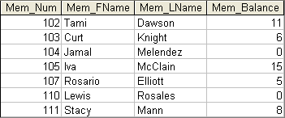

1. Write a query to display the minimum balance, maximum balance, and average balance for memberships that have a rental.

SELECT MIN(Mem_Balance) AS minimum_balance, MAX(Mem_Balance) AS maximum_balance, ROUND(AVG(Mem_Balance),2) AS average_balance

FROM (SELECT DISTINCT Mem_Num FROM rental) r, membership m

WHERE r.Mem_Num=m.Mem_Num

|  |  |  |
| --- | --- | --- |
| MINIMUM_BALANCE | MAXIMUM_BALANCE | AVERAGE_BALANCE |
| 0 | 15 | 6.43 |

1. Write a query to display the rental number, rental date, video number, movie title, due date, and return date for all videos that were returned after the due date. Sort the results by rental number and movie title.

SELECT r.Rent_Num, Rent_Date, v.Vid_Num, Movie_Name, Detail_Duedate, Detail_Returndate

FROM rental r, movie m, detailrental d, video v

WHERE r.Rent_Num=d.Rent_Num AND d.Vid_Num=v.Vid_Num AND v.Movie_Num=m.Movie_Num AND Detail_Returndate > Detail_Duedate

ORDER BY r.Rent_Num, Movie_Name

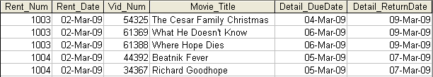

1. Write a query to display the rental number, rental date, video number, movie title, due date, return date, detail fee, and number of days past the due date that the video was returned for each video that was returned after the due date. Sort the results by rental number and movie title.

SELECT r.Rent_Num, FORMAT(Rent_Date, "DD-MMM-YY"), v.Vid_Num, Movie_Name, FORMAT(Detail_Duedate, "DD-MMM-YY"), FORMAT(Detail_Returndate, "DD-MMM-YY"), (Detail_Returndate - Detail_Duedate) AS Days_Past_Due

FROM rental r, movie m, detailrental d, video v

WHERE r.Rent_Num=d.Rent_Num AND d.Vid_Num=v.Vid_Num AND v.Movie_Num=m.Movie_Num AND Detail_Returndate > Detail_Duedate

ORDER BY r.Rent_Num, Movie_Name

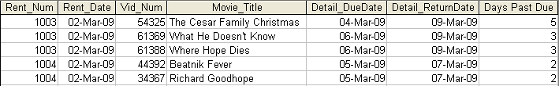

1. Write a query to display the rental number, rental date, movie title, and detail fee for each movie that was returned on or before the due date.

SELECT r.Rent_Num, FORMAT(Rent_Date, "DD-MMM-YY"), Movie_Name, Detail_Fee

FROM rental r, movie m, detailrental d, video v

WHERE r.Rent_Num=d.Rent_Num AND d.Vid_Num=v.Vid_Num AND v.Movie_Num=m.Movie_Num AND (Detail_Returndate < Detail_Duedate OR Detail_Returndate = Detail_Duedate)

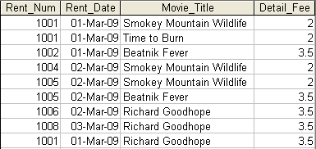

1. Write a query to display the membership number, last name, and total rental fees earned from that membership. The total rental fee is the sum of all of the detail fees (without the late fees) from all movies that the membership has rented.

SELECT m.Mem_Num, Mem_Lname, Mem_Fname, SUM(Detail_Fee) AS Rental_Fee_Revenue

FROM membership m, rental r, detailrental d

WHERE m.Mem_Num=r.Mem_Num AND r.Rent_Num=d.Rent_Num

GROUP BY m.Mem_Num, Mem_Lname, Mem_Fname

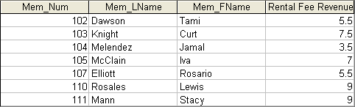

1. Write a query to display the movie number, movie genre, average movie cost of movies in that genre, movie cost of that individual movie, and the percentage difference between the average movie cost and the individual movie cost (result shown in Figure 26). Note: the percentage difference is calculated as the cost of the individual movie minus the average cost of movies in that genre, divided by the average cost of movies in that genre multiplied by 100. For example, if the average cost of movies in the “Family” genre is $25, if a given Family movie cost $26, then the calculation would be ((26 – 25) / 25 * 100), which would work out to be 4.00%. This indicates that this movie costs 4% more than the average Family movie.

SELECT m.Movie_Num, m.Movie_Genre, x AS Average_Cost, Movie_Cost, ROUND(((Movie_Cost - x) / x)* 100 ,2) AS Percentage_Difference

FROM movie m, (SELECT Movie_Genre, ROUND(AVG(Movie_Cost),2) AS x FROM movie GROUP BY Movie_Genre) s

WHERE s.Movie_Genre = m.Movie_Genre

